**Come Join Us on Saturday, August 19th for an Evening at the Farm**

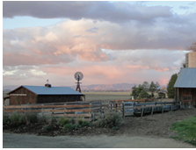

Come join The Farmer and Adele on Saturday, August 19th for an Evening at the Farm.

The evening starts at 5:30 p.m. with live, local music from Ash & Andrea Ganley. Enjoy appetizers & non-alcoholic drinks and Colorado wine from Book Cliff Winery (sold separately).

Dinner will be served at 6:45. Chef Mary-Frances Heck will use fresh, local meat and produce to prepare a wonderful 4-course meal. Mary-Frances is a chef and cookbook author whose passion for food is rooted in a deep respect for agriculture and a celebration of peak season ingredients.

Dinner will be followed by dessert and tea/coffee and finally, a movie.

Cost for the evening is $95.00 per person. Wine sold separately.

Limited seats available. Please e-mail [303farmerandadele@gmail.com](mailto:303farmerandadele@gmail.com) to reserve your spot now.

Vegetarian dinner option available.